**Assignment 1**

**Display Post Details**

BlogPool is a blogging site that helps people to share their knowledge through blogs of various categories. (Tech, Books, Comics, Culture, Food, Music, etc). In this platform, users can compose the post that they are thinking in their minds and share across the globe. BlogPool is a budding platform and needs more features to be embedded. Use Angular Component and design a page to implement the feature of displaying post details.

**Sample Screenshot 1:**

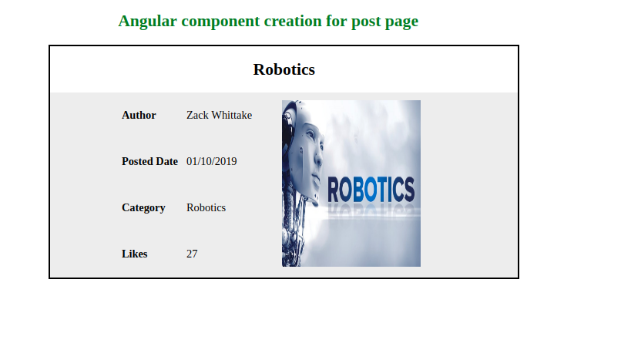

**Sample Screenshot 2:**

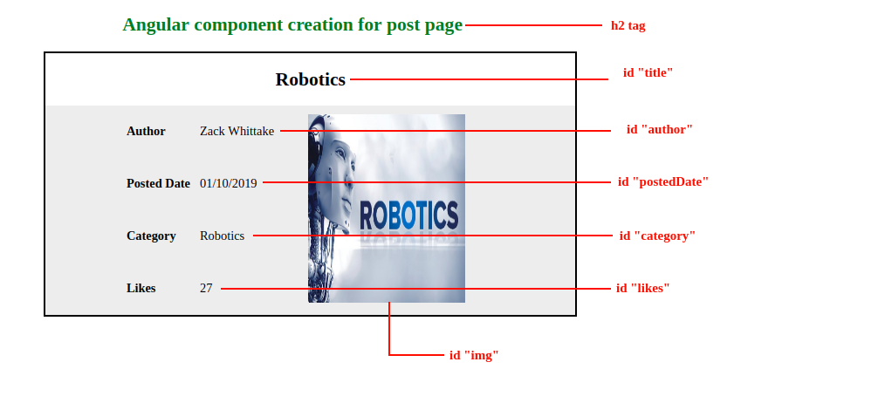

**Additional Constraints :**

* Declare the following attributes in the component class:

|  |  |
| --- | --- |
| **Attribute Name** | **DataType** |
| title | string |
| author | string |
| category | string |
| postedDate | string |
| likes | number |

* Store the post details in the Component.
* Do follow the UI Constraints given in the below screenshots.

**Assignment 2**

**Display product details using Property Binding**

'Cold Stone Creamery' is one of the biggest ice cream selling shops. The company wished to extend its sales to all over the globe online. So they decided to create an online web application to sell their products. The users can purchase the products based on the stocks available.  
Use Angular Component and design a page to implement the display product details.

**Sample Screenshot 1:**

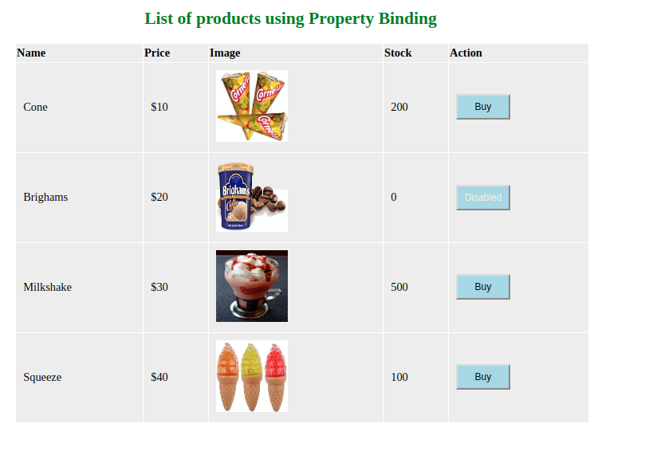

**Sample Screenshot 2:**

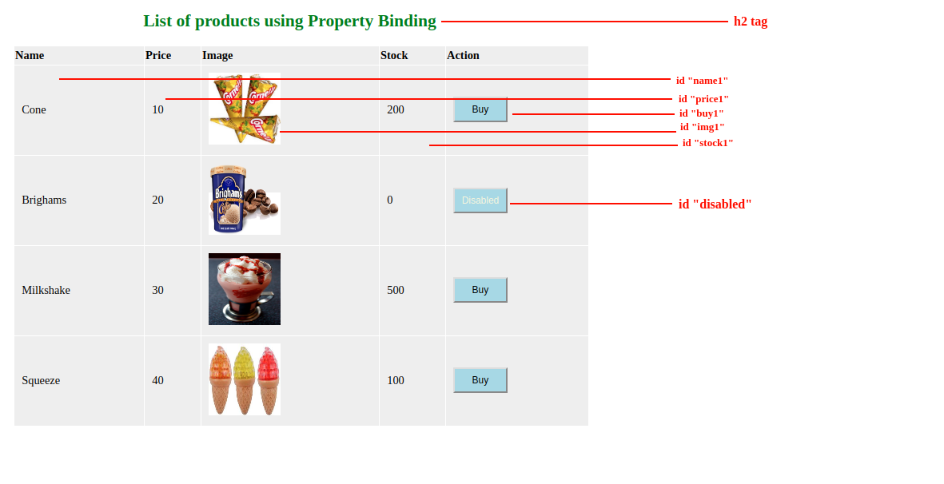

Create a Product Class in Product.ts with the following attributes:

|  |  |
| --- | --- |
| **Attribute Name** | **DataType** |
| name | string |
| price | number |
| imageUrl | string |
| stock | number |

**Constraints :**

* Create a Product array that has the above-mentioned attributes.
* Populate every object value and display it on the HTML page using Product Array.
* Display the product details as mentioned in the screenshots.
* Add a stock attribute to the product.
* Display every product detail using property binding.
* Refer to the screenshot for id specifications in all four products like name1, name2, name3, name4.